
Registered association for the promotion
of medical care and social support in
Northern Samar, Philippines

Bugko, August 2025

Dear members, dear friends, and supporters of Mabuhay!

Immediately after Easter, Dr. Christian Nick was succeeded by Dr. Julia Goller, ensuring the clinic remained in good hands. I had already begun revising the website with Bärbel Nick, so I was able to continue this work. Many patients who had seen Dr. Nick returned with different ailments and were pleased to be treated by a German doctor again. Dr. Goller came from near Mainz and had already worked with German Doctors in Mindoro in January. Every day, patients of all ages came to the clinic. It was a change for Dr. Goller, as she is a gastroenterologist, and general medicine was required here. Many patients came with high blood pressure and diabetes, and even Dr. Goller found it difficult to understand why they didn't take their medication regularly. They seemed to think that if they took blood pressure medication for a month, for example, it was enough, since their blood pressure would then be fine. After some time, they come back with high blood pressure or even a stroke and don't understand why. It's the same with diabetes. A great deal more public education is needed if we want to reduce the number of early strokes. I was very glad that she took over the clinic for four weeks, which gave me time for paperwork that had been piling up for a long time.

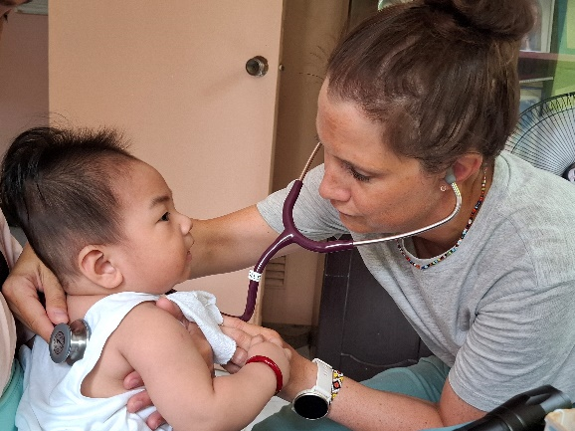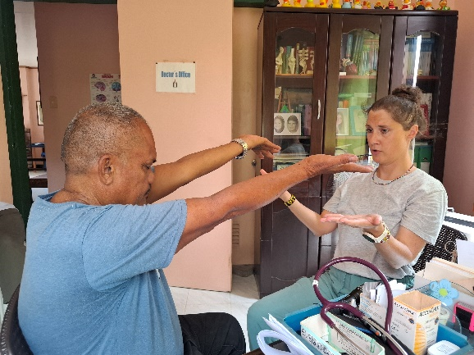

On May 6th, I was able to attend a conference on Medical Technology and Digital Health at the German Chamber of Commerce in Manila. It was very interesting, and at times even alarming, to see how far these technologies have already advanced in medicine, and I quickly realized how long it had been since I'd been in Germany. All the exhibitors were from Germany, where these technologies have been successfully used for quite some time.

Besides the conference, I met again with Mr. Michael Schmermer, the President of Siemens Healthiners, Inc. Philippines, and Pukar Chettri from Caritas Germany, as well as various representatives from the German Club. On the last day, I met Enis Labiadh, whose company has developed a backpack-sized X-ray machine. It weighs only 8.5 kg. It's truly astonishing what these new technologies can do. It was a very busy few days.

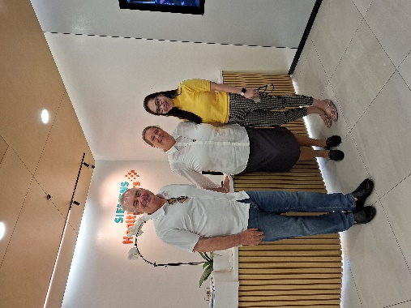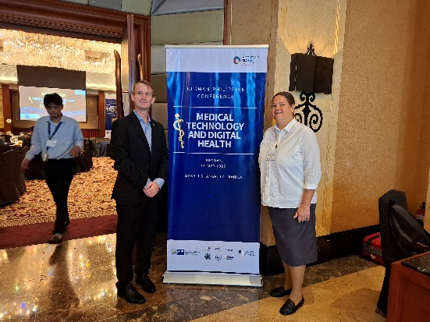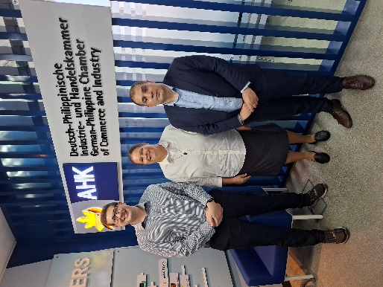

Two days after my return, Jaqueline B. and Manuel V., both experienced dentists, came to see us. Jaqueline B. is originally from Romania, where she studied and now works near Aachen in her father's dental practice. Manuel V. is originally from Italy, studied in Spain, and completed his postgraduate training in Germany. That's how the two met. He will soon be opening his own practice in Italy. Both had many patients and were saddened by how many teeth had to be extracted. Removing front teeth, especially from young patients, is particularly painful for any dentist, as it can, in a way, disfigure the face and affect speech.

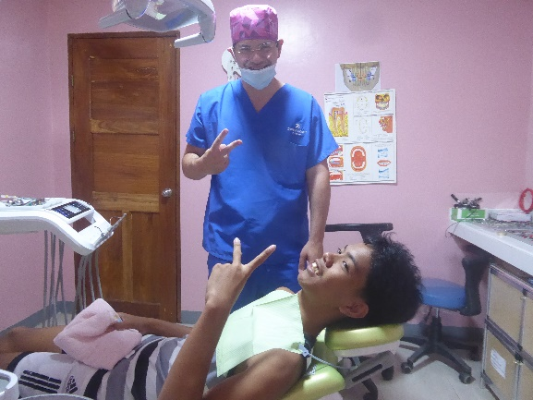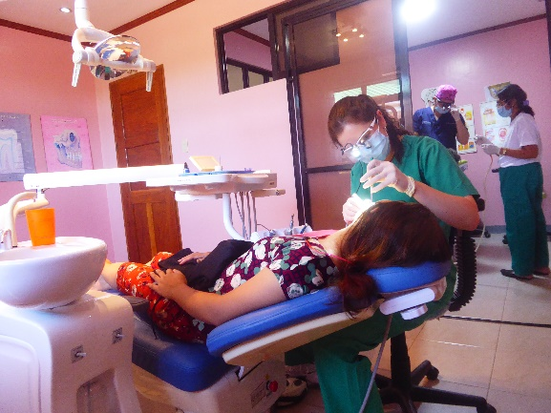

Elections were held again in the Philippines on May 12th. Voters elected representatives from the Senate and Congress to governors, mayors, and their respective councils. As always, voter turnout was high, but unfortunately, vote buying is still common in the provinces. Houses were plastered with posters, making it difficult to see the doors. Visual appeal is important to voters. Voting, as in Germany, took place in schools, and everyone who voted was marked.

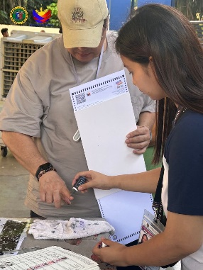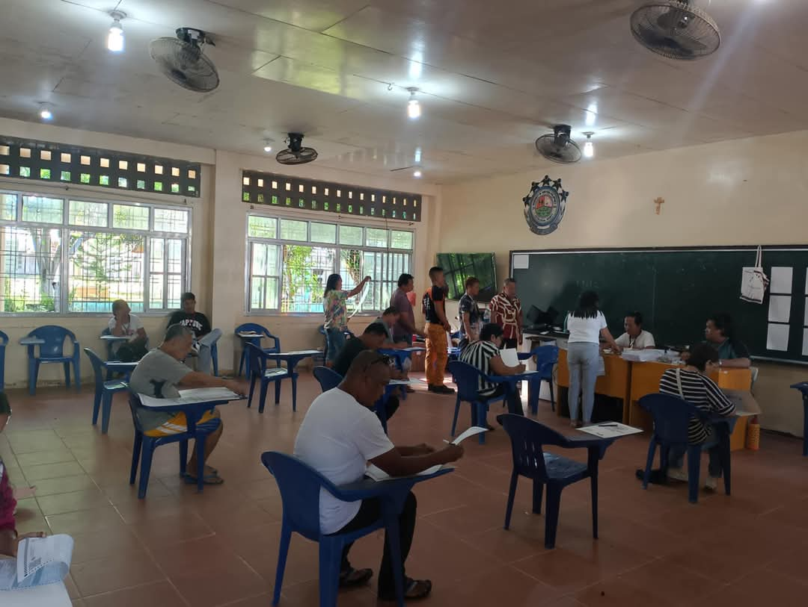

Meanwhile, the garden project continued steadily. On May 10th, the second greenhouse with a hydroponic system was installed. Like the previous one, it is equipped with an automated system to supply the young lettuce plants and now also peppers with nutrients. We are very grateful to the East Asia Association Bremen e.V. for approving the second greenhouse. We were also able to expand the growing area somewhat, allowing us to cultivate additional vegetables. This year, the focus is on achieving a continuous harvest. To this end, the irrigation system has been expanded, and the workers continue to receive regular training.

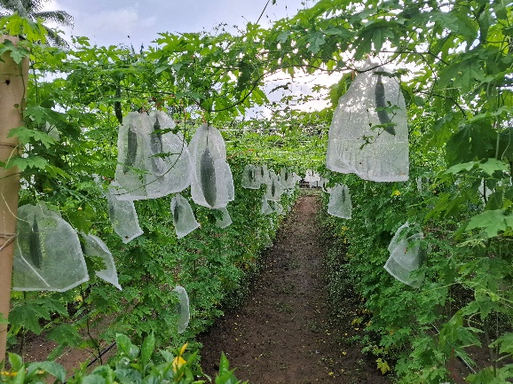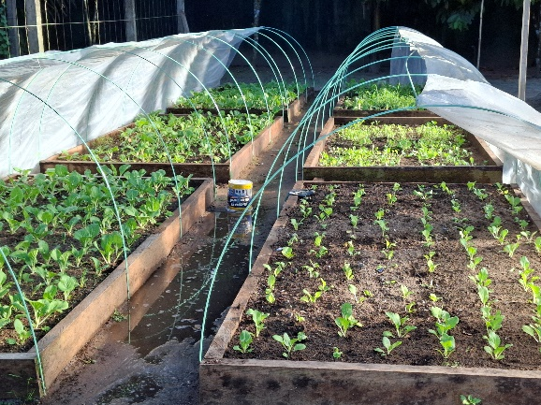

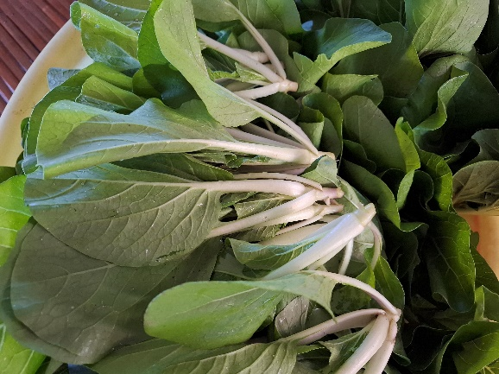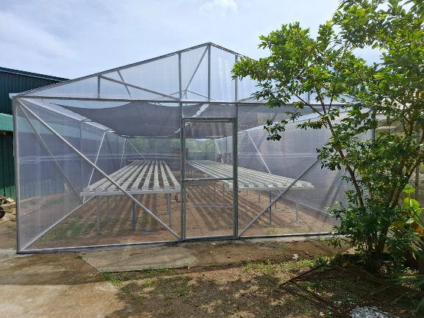

More good news came from Bonn. The Rotary Club in Bonn is funding a solar power system for our guesthouse, marking the beginning of our journey to using renewable energy, which will also help us reduce our very high electricity costs. It is very important to us to also supply the other buildings with solar energy, as it makes sense to utilize the high solar intensity in the tropical Philippines. The next step is to supply the clinic building with solar power. We hope to find more donors who can support us in this endeavor.

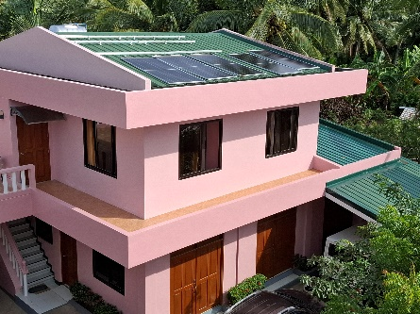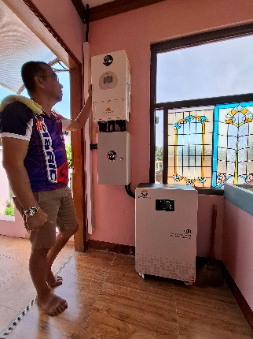
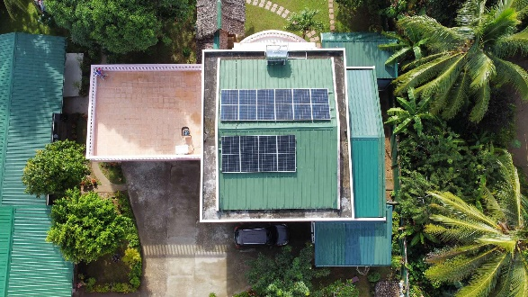

From May 29th to 31st, we took our volunteers on a team-building trip. We drove to San Jorge, about three hours from the clinic, to Island Nature Spring. It's a small oasis in the middle of nature, situated by a waterfall. Besides many conversations, there were also some group games that strengthened team spirit, and the whole team had a lot of fun. There was a lively exchange of ideas, and existing problems were also addressed.

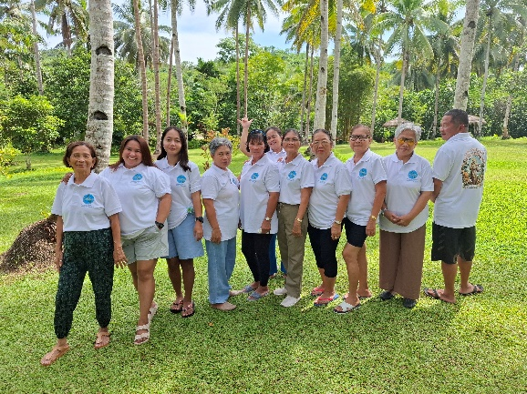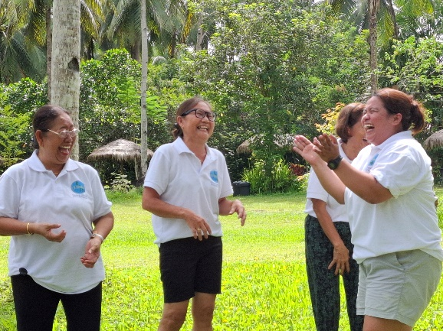

Shortly after our return to the clinic, the German Dentists' Aid Organization, represented by Dr. Klaus Sürmann and Dr. Klaus Winter, pledged additional solar batteries. We are committed to expanding the clinic's solar system to reduce our very high electricity costs and also to counteract the power outages, which unfortunately still occur frequently here, as these damage our medical equipment. Dr. Winter immediately embraced the idea and financed the extra batteries. As always, the German Dentists' Aid Organization is supporting us. Photos will be included in the next report, as the installation will not take place until August after our trip to Germany.
On May 10th, the Department of Health (DOH) visited our laboratory. This is an annual visit to inspect our records, equipment, and reagents. We have one of the few independent laboratories in northern Samar, meaning it's not attached to a hospital, and we always strive to meet the DOH's strict inspection requirements. This isn't easy, as new requirements are introduced every year. It's not always easy to understand, but if you don't meet them, they shut the laboratory down.

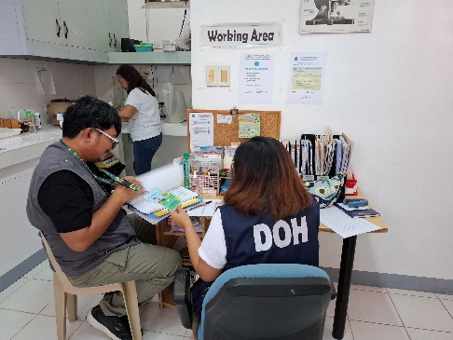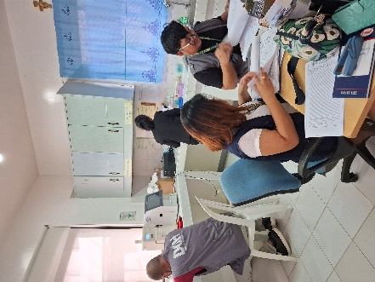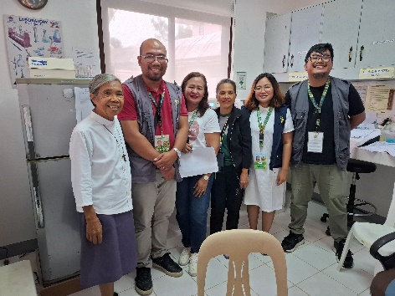

We were able to expand the nutrition program to 130 children after Oceanic – Hospitality Training Center and the German Club Manila joined forces to help even more children. The number of malnourished children is still very high, and we are therefore pleased that we were able to expand the program.

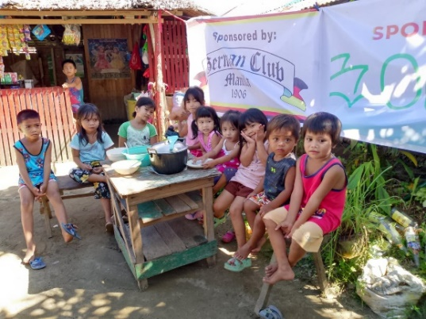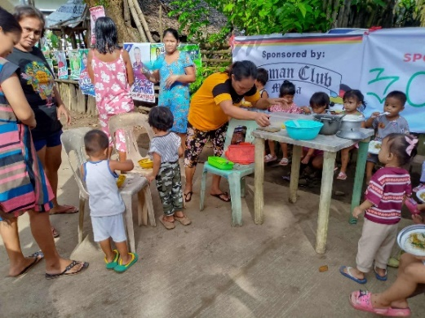

On June 17th, we traveled to Germany to report back on the project's progress, the support we need, and any challenges we're facing. As you've probably read, things are always happening here. This year, we stayed until the end of July, as we also had a lot to discuss with the team at Mabuhay - Hilfe zum Leben e.V. (Mabuhay - Help for Life).

While we were still on our way back to Bugko, we received a huge donation of eyeglasses through the Rotary Club Bornheim in conjunction with Optik Herrmann from Heimerzheim. Over nine boxes were donated, and our patients will be thrilled to be able to choose their own pair. They will be included in the next shipment and will be a great help to patients with visual impairments.
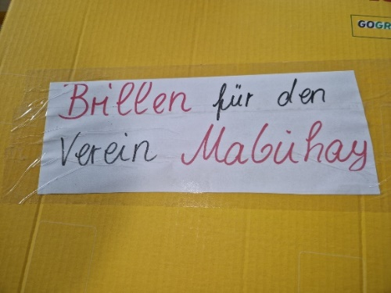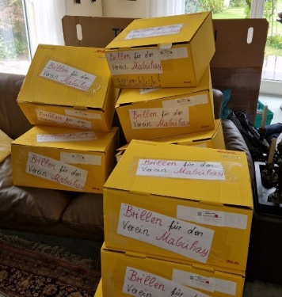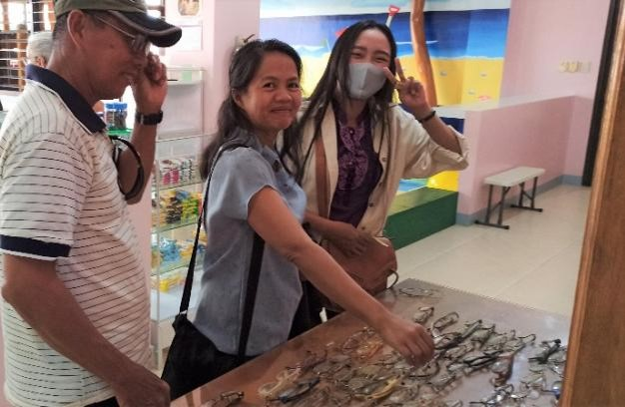

The dental clinic reopened on August 4th. Vanessa S. and Sarah F. came from Freiburg, and Sebastian M. from Mainz.

They are gaining valuable experience here and already saw many patients on their first day back after the rather long break.

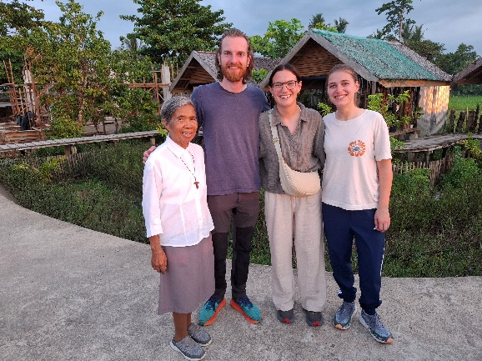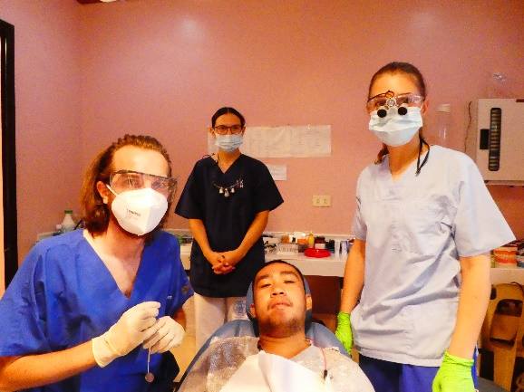

We thank everyone who continually supports us, whether through financial donations or in-kind donations such as disinfectants, clothing, shoes, toys, eyeglasses, medical supplies, medications, etc. The list is long, and I can't possibly mention them all. THANK YOU, THANK YOU!!

I wish you all a wonderful summer and hope to see you again in January at our annual general meeting.

Warmest regards,

Yours sincerely,

Sabine Korth

Donation: Mabuhay – Hilfe zum Leben e.V. Amtsgericht Bonn
Sparda Bank West eG Geschäftsstelle: VR 8364
BLZ 370 60590 Kaiserstrasse 11
Konto-Nr.. 3651274 53332 Bornheim
IBAN : 20 3706 0590 0003 6512 74
BIC : GENODED 1SPK www.mabuhay-ev.de

